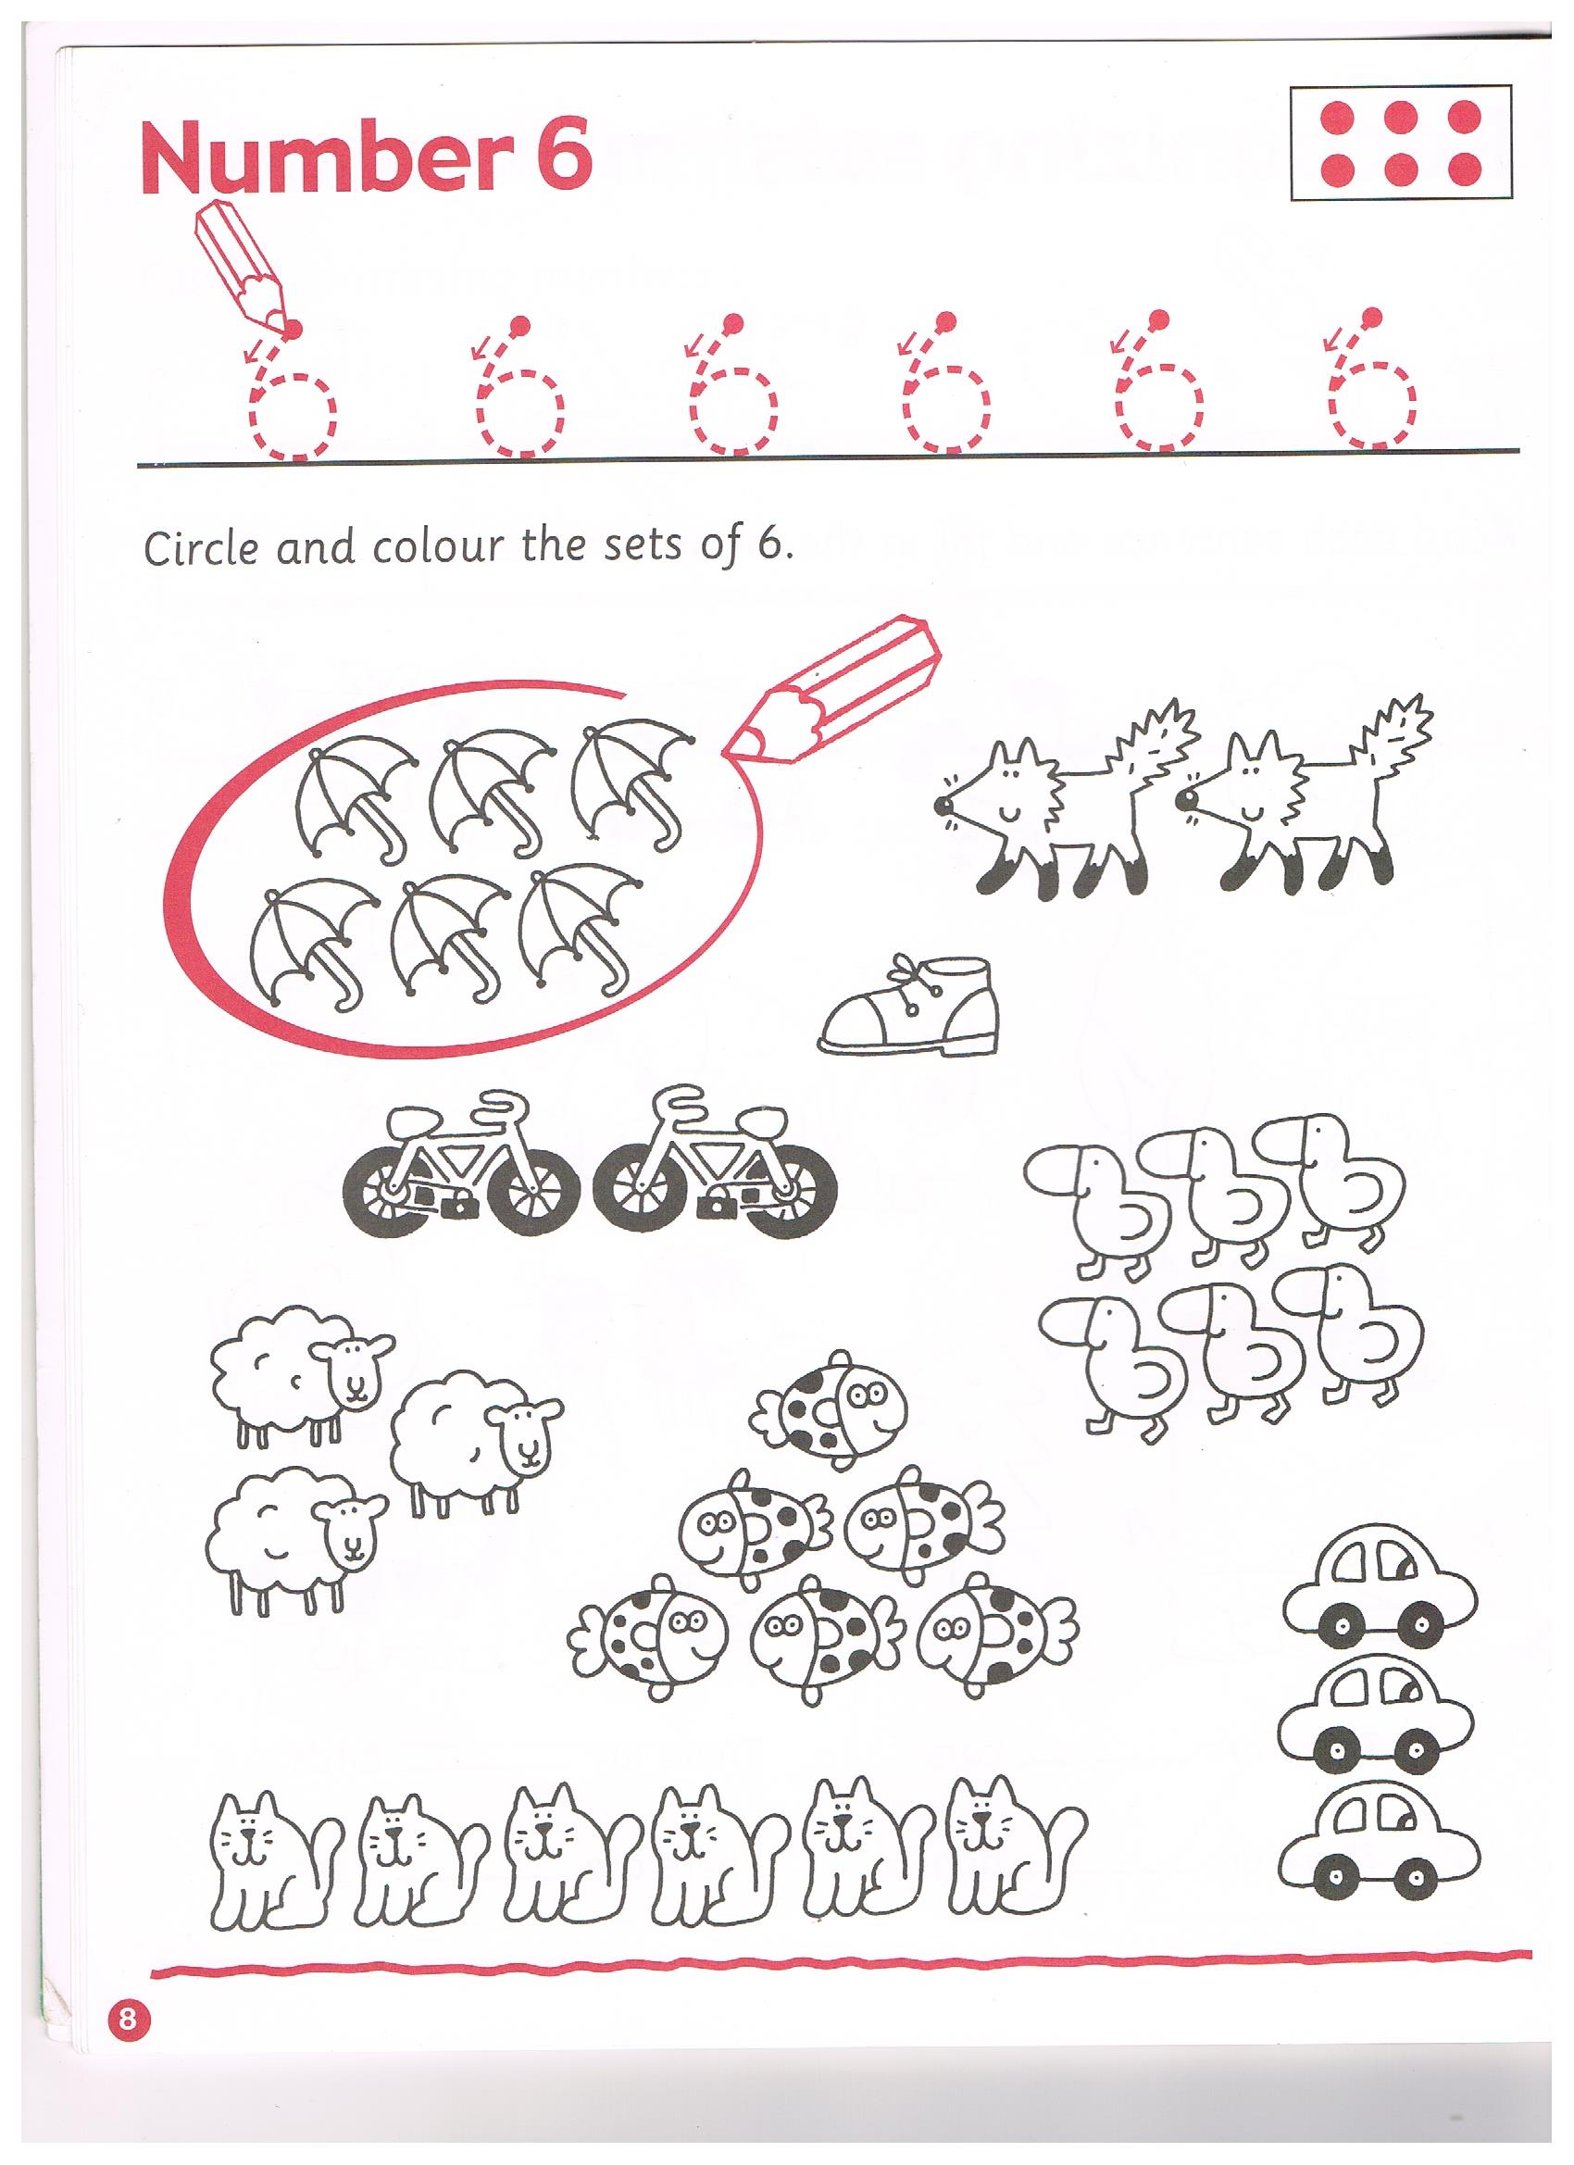
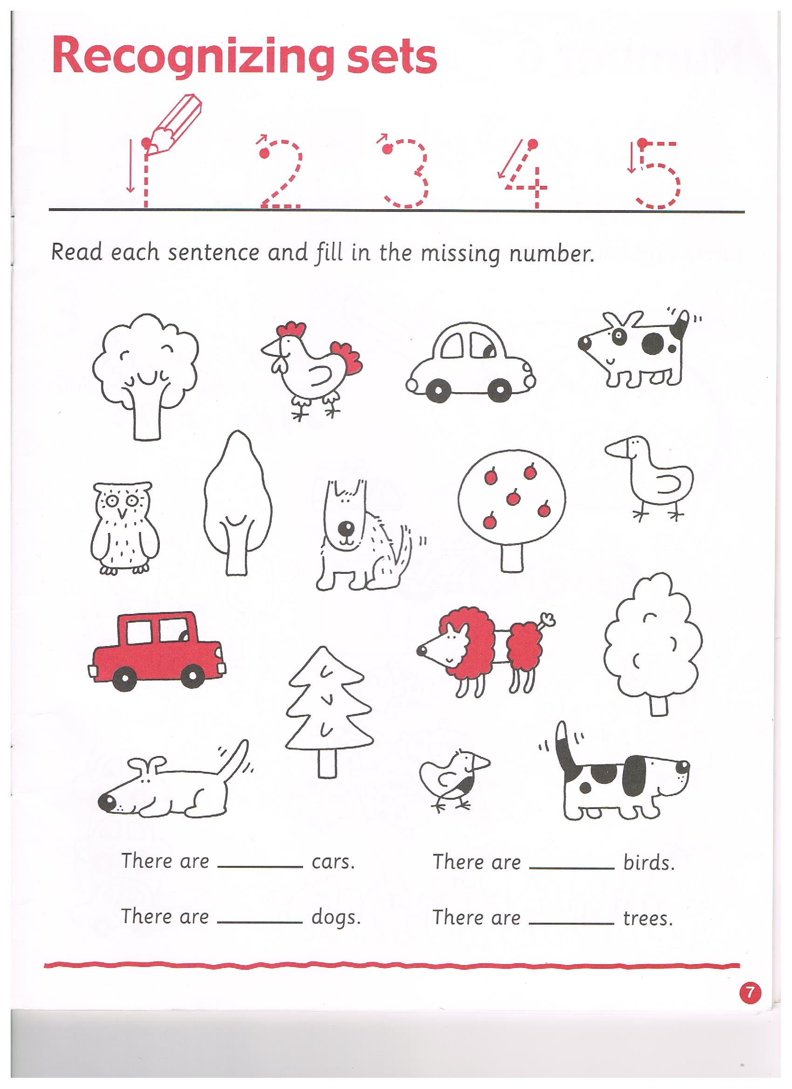
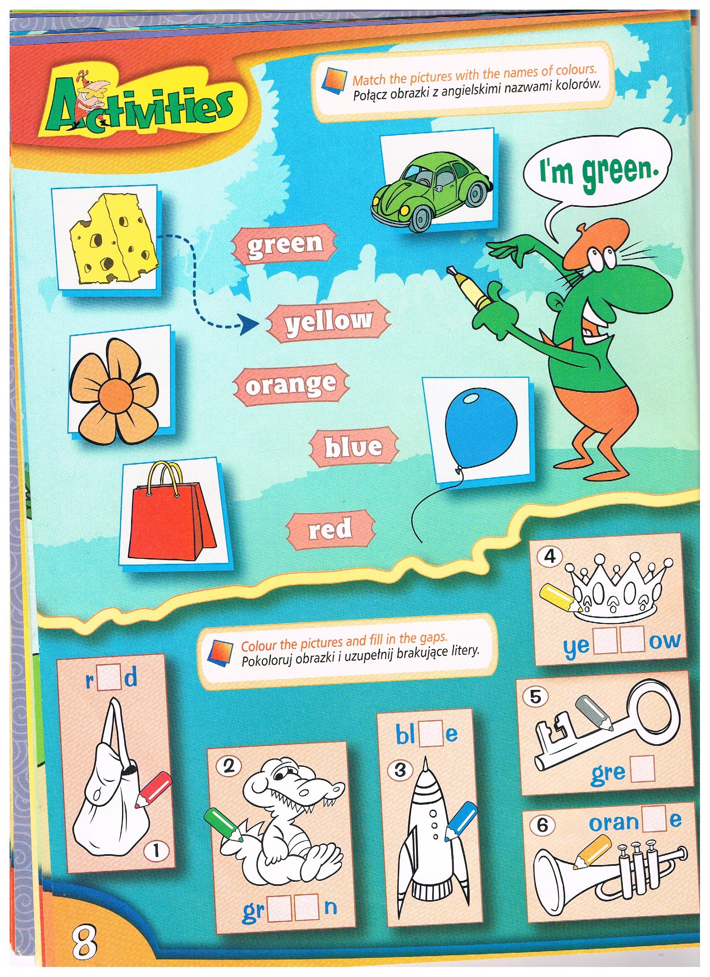
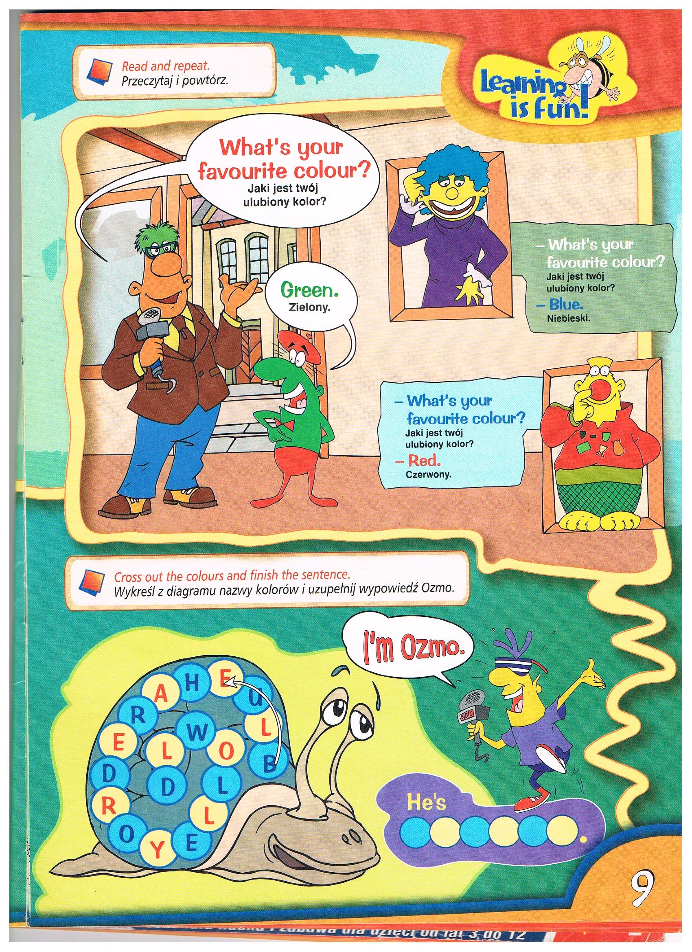
Zaśpiewajcie
https://www.youtube.com/watch?v=bt7-Hcy8JPs
https://www.youtube.com/watch?v=t99ULJjCsaM
https://www.youtube.com/watch?v=wCfWmlnJl-A
https://www.youtube.com/watch?v=fPMjnlTEZwU
https://www.youtube.com/watch?v=RuqvGiZi0qg

